**UNIVERSITY OF ENGINEERING AND TECHNOLOGY, LAHORE**

**(NAROWAL CAMPUS)**

**­**

**NAME :**

**ABDULAHAD HUSSAIN**

**ROLL NO. :**

**549**

**SECTION:**

**A**

**SUBJECT:**

**PROGRAMING FUNDAMENTAL**

**LAB #03:**

**I/O Library Header Files:**

In C++, I/O is a sequence of bytes, called a stream, from source to destination. Bytes are usually characters, unless program requires other types of information (images, sound)

Input stream: sequence of characters from an input device to the computer.

Output stream: sequence of characters from the computer to an output device

**Input And Output Function:**

The C++ standard libraries provide an extensive set of input/output capabilities which we will see in subsequent chapters. This chapter will discuss very basic and most common I/O operations required for C++ programming.

C++ I/O occurs in streams, which are sequences of bytes. If bytes flow from a device like a keyboard, a disk drive, or a network connection etc. to main memory, this is called **input operation** and if bytes flow from main memory to a device like a display screen, a printer, a disk drive, or a network connection, etc., this is called **output operation**.

**Cin:**

The predefined object **cin** is an instance of **iostream** class. The cin object is said to be attached to the standard input device, which usually is the keyboard. The **cin** is used in conjunction with the stream extraction operator, which is written as >> which are two greater than signs as shown in the following example.

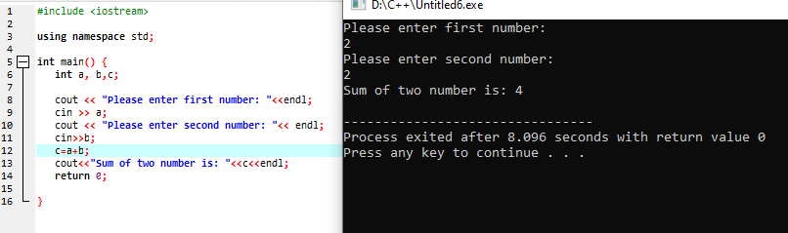

**Cin.get():**

The cin.get () C++ function is used to access the character array. This is a very basic function in the c++ programming language that is used to get input from the user. The cin.get() C++ function also includes the white space characters into it.

**cin.ignore():**

The cin.ignore() function is used to ignore or clear one or more characters from the input buffer. 

**cin.peek():**

**cin.peek()** returns the next input character without taking it out of the input stream.

**cin.putback():**

**cin.putback()**, as the name suggests, puts a character back to the beginning of the input stream. One thing noteworthy is that you must read a character before you use this function.

**Manipulator:**

Manipulator are instructions to the output stream that modify the output in various.

**Manipulators** are helping functions that can modify the input/output stream. It does not mean that we change the value of a variable, it only modifies the I/O stream using insertion (<<) and extraction (>>) operators.

**set precision():**

**set precision in C++** is a manipulator used to set the precision of the floating-point number after the decimal in the output stream. Set precision() function is defined inside the header file. set precision in C++ works to prevent the loss of information.